Institution Details

Province | Punjab | City | Lahore
Institution | Superior University | Campus | Gold Campus
Department | Computer Science | Degree Level | Bachelors
Degree Program | BSCS | Telephone | 042-381-042-21
Fax

Supervisor Details

Name | Mam Arshia | Mobile
Office No | Office # 1 | Email
Designation | Lecturer | Qualification

Head of Department Details

Name | Sir Irfan ud Din | Mobile No.
Email | irfan@superior.edu.pk

Project Group Details

Team Lead | Team Member's Name | Team Member's Mobile | Team Member's Email | Team Member's Institution Registration Number | Team Member's Year of Study | Team Member's Semester | Team Member's CNIC
Team Lead | Shuja Ul Hassan | 0321 1067383 | Bcsm-f19-266@superior.edu.pk | Bcsm-f19-266 | 3rd year | 6th Semester | 34601-9857730-7
 | Ahmad Imran | 0315 9835556 | Bcsm-f19-277@superior.edu.pk | Bcsm-f19-277 | 3rd year | 6th Semester | 35201-4280282-7
 | Umair Ali | 0322 4344698 | Bcsm-f19-258@superior.edu.pk | Bcsm-f19-258 | 3rd year | 6th Semester | 35202-0750635-7
 | Hamza Azeem | 0320 1489596 | Bcsm-f19-506@superior.edu.pk | Bcsm-f19-506 | 3rd year | 6th Semester | 35202-9479800-1
 | Sami Ullah | 0346 3846438 | Bcsm-f19-468@superior.edu.pk | Bcsm-f19-468 | 3rd year | 6th Semester | 33105-8501720-9

Project Details

Project Title | ezFleet
Project Area of Specialization | Online Cargo Automated System
Project Start Date |  | Project End Date
Project Summary (less than 2500 characters) | ezFleet is an AI based software for local truck transporters in Pakistan who need a software system to manage their shipments efficiently. Unlike other software systems, it provides hassle-free route and vehicle management. Furthermore, it eliminates paperwork, making it environmentally friendly.  There has been a significant paradigm shift in the world cargo industry. Use of modern technology to improve and enhance services in the trucking industry has certainly picked up in recent times but is mostly limited to large and medium size companies, while the sector is dominated by small size companies.  All the manual work, lengthy paperwork is withering away with digitalization taking its space, providing assured results and better revenue. ezFleet ensures that the process becomes hassle-free, error-free and the shipments managed efficiently. Moreover, these systems are designed for varied requirements like managing warehouse, revenue or other factors.  With the advancement in technology, the management software also provides real-time information for tracking without any lag. ezFleet system facilitates, execute and track routes of incoming and outgoing shipments for cargo and freight management. The entire process starts from the initiation of the order to the final delivery.  Major market segment of ezFleet is Local truck transport companies in Pakistan which don’t have or need software system to manage their business routines. Almost 79% of truck cargo market consist of small cargo companies which do not have any type of software system.  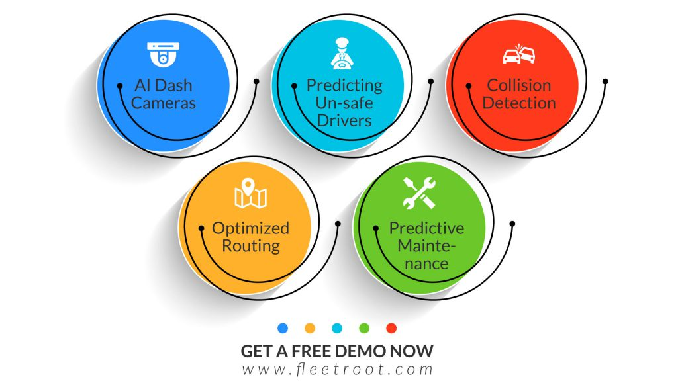

Project Objectives (less than 2500 characters)
- Better Logistic Management
With such logistics automation system there are no additional resources needed to manage your logistics, freight, and transportation departments, even as your business grows and ships more freight. As your company grows and ships more freight. Improved technology has also increased productivity in the supply chain, minimizing costs and errors.
- Well Organized Path Management
With using logistics automation system, one can find a well-organized route from source to destination point without wasting much time and hassle.
- Adequate Documentation Maintenance
Document management software helps logistics companies avoid the bottlenecks that cause delays in deliveries and shipments. It provides a centralized system for managing freight bills, bills of lading, proof of concept, and other essential documents. With logistic automation system, documents and records can be kept in a very professional way without affecting the internal business process. Users can easily export the records when needed.
- Facility to track Delivery
Logistic automation system allows you to track the consignments. Granting you the ability to get status updates of the delivery without even calling the delivery man.
- Maintenance
AI will help track the maintenance needs of their fleets. It can track the status of the vehicles in a fleet and report the statistics and measurements, like driving data. Then, during maintenance, the enterprise can see real-time updates on when the truck or its parts will need maintenance.
- Safety
AI-enabled features can monitor and prevent fraud from the drivers if it is not driving truck or stop for an extra time or changes direction of vehicle.

Project Implementation Method (less than 2500 characters)
ezFleet Desktop Application will be made using Java programming language (Java Swing). The Swing API provides a comprehensive set of GUI (Graphical User Interface) components and services which enables the development of commercial-quality desktop and Internet/Intranet applications.

Core Tasks:

- AI Based Route Management and Monitoring:
We will implement an AI modal in the application which will monitor the truck route using Google Map Api’s and installed GPS tracker. AI modal will look for any different behavior in route of truck and notify details to owner about it.

- Logistics Management:
ezFleet with proper detail of shipment and supply chain will help user to manage shipment more efficiently and reducing cost on each shipments.

- Documentation Management:
All data related to shipment will be stored and hosted on the cloud. Software will provide all type of documents generation related to business like detail and receipt of shipment, whole week income sheet, excel sheet generation for all categories.

- Maintenance:
AI modal in software will help track the maintenance needs of their fleets. It can track the status of the vehicles in a fleet and report the statistics and measurements, like driving data. Then, during maintenance, the enterprise can see real-time updates on when the truck or its parts will need maintenance.

- Safety:
AI-enabled features can monitor and prevent fraud from the drivers if it is not driving truck or stop for an extra time or changes direction of vehicle.

- Pricing the shipment:
Software will help user to best price the ship according to the weight and destination.

- Finding a replacement in the event of a falloff:
Through usage of Artificial Intelligence if a vehicle falloff then he can find nearest vehicle and automatically can notify manager and near vehicle driver.

Benefits of the Project (less than 2500 characters)
In market there are many software which are giving support to the cargo system but our software system will provide some the feature which are more advanced from the other system.

Features which will get us on top of market are:
- Business activities automation:
Automation of activities through software brought consistency of quality to service provided by a company and has enabled the company to scale up and scale down based on the demand conditions in the market.
- Secure System:
ezFleet end-to-end encryption and secure storing of data make it more reliable among competitors. Protection from any cyber attack ensures safety of software
- Documentation Management:
Generation of strong Financial Statement for business can increase Return on Sales (RoS) & other metrics.
- Vehicle Monitoring:
Provide real-time updates to user about his vehicles. Application will monitor the truck route using Google Map Api’s and installed GPS tracker.
- Awareness about Software:
Increase Level of Social Concerns & Awareness in Truck Transport Society related to technology.
- Profit:
10% reduction in fuel cost can result in 31% increase in profit.

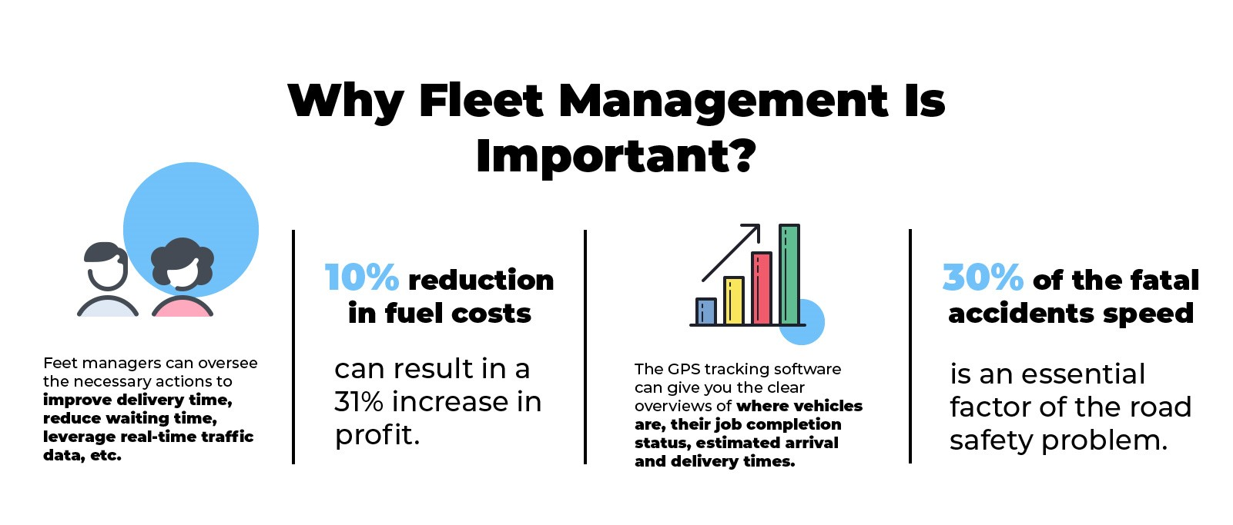
ezFleet price will demand on number of vehicles in the company so we have estimated total 15% of net profit on each sale until we reach our breakdown point. After that we will earn 40% of net profit on each sale.

- In-App Purchases.
We are going to sell products through referral marketing in our app. These products will be related to cargo business. Revenue generation from this won't be very high in first year. But it will grow in coming years. And we will generate amount of Rs. 150,000 to 170,000 with the help of in app purchases.

- Subscription:
We'll also earn through providing subscription on premium features yearly. Premium subscription which will include special features which will be given for Rs. 12,000

Technical Details of Final Deliverable (less than 2500 characters)

Complete functional desktop application with installed GPS trackers on the vehicles.

Final Deliverables:

ITEM | Technical Detail | Timeline
ezFleet Application | Application installer to be installed on the client computer with the integration of AI & ML modal and GPS Tracker. | 8 weeks
GPS Tracker | GPS Tracker will be installed on the client vehicle. All vehicle will share its live location with application through GPS. GPS integration will be done using its serial number and software installation. | 1 week (Import from china)
AI & ML Modal | All AI & ML modal used in application such as route monitoring modal, maintenance modal, price suggestion modal, etc. will be pre-installed in the application. | 4 weeks
Google Map Api’s | Google Map Api’s integration with the GPS tracker to show vehicle on the Map. | 1 week for integration.
Printer | Printer will be attached with the computer and integrated with the application to print important document from the application | 1 day for integration.

- Total Cost in making of ezFleet will be Rs. 75,550.

- ezFleet breakeven point is 4 units which will be reach within 3 month.

- Payback Period will be 9 months.

Final Deliverable of the Project | ezFleet Desktop Application with GPS Trackers and AI and ML modal.
Type of Industry | Transportation
Technologies | Artificial Intelligence, Machine Learning, GPS, Google Map API’s
Sustainable Development Goals | Sustainable development Goals:  - Increase Level of Social Concerns & Awareness in Truck Transport Society related to technology.  - Eliminate Paper work in the truck transport industry.  - Customer Support & Platform Development for consumer to resolve their issues.

Project Key Milestones

Elapsed time in (days or weeks or month or quarter) since start of the project | Milestone | Deliverable
2 weeks. | Planning and designing of ezFleet. | Approval of Design and Plan.
8 weeks. | Completion of Main Functionalities. | Installation of ezFleet for useful feedback.
2 weeks. | Feedback from stakeholders and fixing defects. | First version of ezFleet to be released for sale.
12 weeks. | Marketing and successful sale of minimum 30 units of ezFleet. | Survey report of marketing and income sheet for sale evaluation.
2 weeks. | Survey and Feedback. | Reports related to the usage of ezFleet.

Project Equipment Details

Item Name | Type | No. of Units | Per Unit Cost (in Rs) | Total (in Rs)
Computer |  | 1 | Rs. 50,000 | Rs. 50,000
GPS Tracker |  | Depend on no of vehicle company owned | Rs. 1,800 | Rs. 9,000 (5 units)
Printer |  | 1 | Rs. 20,000 | Rs. 20,000
Google Api’s |  | 40,000 hits (min) | Rs, 360 per 1000 hits | Rs 15,000 (40,000 hits)
I affirm that all information submitted through this FYP application is correct and complete as to my best knowledge. I further agree that Ignite can approve, reject, defer or cancel this FYP application without mentioning any reason at any stage of NGIRI 2019. Information cannot be changed after submission.

